**Post covid Multilinear regression model**

### ANOVA for Cubic model

**Response 1: Ozone**

|  |  |  |  |  |  |  |
| --- | --- | --- | --- | --- | --- | --- |
| **Source** | **Sum of Squares** | **df** | **Mean Square** | **F-value** | **p-value** |  |
| **Model** | 6.278E+05 | 164 | 3828.13 | 7.56 | < 0.0001 | significant |
| A-PM2.5 | 1138.15 | 1 | 1138.15 | 2.25 | 0.1343 |  |
| B-PM10 | 1497.65 | 1 | 1497.65 | 2.96 | 0.0860 |  |
| C-NO | 318.11 | 1 | 318.11 | 0.6282 | 0.4283 |  |
| D-NO2 | 345.16 | 1 | 345.16 | 0.6817 | 0.4094 |  |
| E-NOX | 332.45 | 1 | 332.45 | 0.6565 | 0.4181 |  |
| F-NH3 | 6.46 | 1 | 6.46 | 0.0128 | 0.9101 |  |
| G-SO2 | 122.68 | 1 | 122.68 | 0.2423 | 0.6228 |  |
| H-CO | 253.42 | 1 | 253.42 | 0.5005 | 0.4796 |  |
| AB | 488.09 | 1 | 488.09 | 0.9639 | 0.3266 |  |
| AC | 947.93 | 1 | 947.93 | 1.87 | 0.1718 |  |
| AD | 935.97 | 1 | 935.97 | 1.85 | 0.1745 |  |
| AE | 950.67 | 1 | 950.67 | 1.88 | 0.1711 |  |
| AF | 135.07 | 1 | 135.07 | 0.2667 | 0.6057 |  |
| AG | 729.38 | 1 | 729.38 | 1.44 | 0.2306 |  |
| AH | 439.03 | 1 | 439.03 | 0.8670 | 0.3522 |  |
| BC | 1417.95 | 1 | 1417.95 | 2.80 | 0.0948 |  |
| BD | 1420.03 | 1 | 1420.03 | 2.80 | 0.0945 |  |
| BE | 1417.75 | 1 | 1417.75 | 2.80 | 0.0948 |  |
| BF | 21.28 | 1 | 21.28 | 0.0420 | 0.8377 |  |
| BG | 3.54 | 1 | 3.54 | 0.0070 | 0.9334 |  |
| BH | 237.12 | 1 | 237.12 | 0.4683 | 0.4941 |  |
| CD | 166.26 | 1 | 166.26 | 0.3283 | 0.5669 |  |
| CE | 159.35 | 1 | 159.35 | 0.3147 | 0.5750 |  |
| CF | 18.14 | 1 | 18.14 | 0.0358 | 0.8499 |  |
| CG | 135.89 | 1 | 135.89 | 0.2684 | 0.6046 |  |
| CH | 242.94 | 1 | 242.94 | 0.4798 | 0.4888 |  |
| DE | 175.62 | 1 | 175.62 | 0.3468 | 0.5561 |  |
| DF | 22.05 | 1 | 22.05 | 0.0435 | 0.8348 |  |
| DG | 188.29 | 1 | 188.29 | 0.3718 | 0.5422 |  |
| DH | 237.75 | 1 | 237.75 | 0.4695 | 0.4935 |  |
| EF | 18.69 | 1 | 18.69 | 0.0369 | 0.8477 |  |
| EG | 160.66 | 1 | 160.66 | 0.3173 | 0.5735 |  |
| EH | 240.91 | 1 | 240.91 | 0.4758 | 0.4906 |  |
| FG | 247.36 | 1 | 247.36 | 0.4885 | 0.4849 |  |
| FH | 148.00 | 1 | 148.00 | 0.2923 | 0.5890 |  |
| GH | 96.93 | 1 | 96.93 | 0.1914 | 0.6619 |  |
| A² | 306.23 | 1 | 306.23 | 0.6048 | 0.4371 |  |
| B² | 317.05 | 1 | 317.05 | 0.6261 | 0.4291 |  |
| C² | 149.82 | 1 | 149.82 | 0.2959 | 0.5867 |  |
| D² | 180.69 | 1 | 180.69 | 0.3568 | 0.5505 |  |
| E² | 169.07 | 1 | 169.07 | 0.3339 | 0.5636 |  |
| F² | 64.30 | 1 | 64.30 | 0.1270 | 0.7217 |  |
| G² | 1933.93 | 1 | 1933.93 | 3.82 | 0.0511 |  |
| H² | 234.02 | 1 | 234.02 | 0.4622 | 0.4969 |  |
| ABC | 537.23 | 1 | 537.23 | 1.06 | 0.3034 |  |
| ABD | 534.15 | 1 | 534.15 | 1.05 | 0.3048 |  |
| ABE | 541.05 | 1 | 541.05 | 1.07 | 0.3017 |  |
| ABF | 1089.05 | 1 | 1089.05 | 2.15 | 0.1430 |  |
| ABG | 726.96 | 1 | 726.96 | 1.44 | 0.2313 |  |
| ABH | 1091.49 | 1 | 1091.49 | 2.16 | 0.1426 |  |
| ACD | 750.18 | 1 | 750.18 | 1.48 | 0.2240 |  |
| ACE | 762.51 | 1 | 762.51 | 1.51 | 0.2203 |  |
| ACF | 211.78 | 1 | 211.78 | 0.4182 | 0.5181 |  |
| ACG | 700.97 | 1 | 700.97 | 1.38 | 0.2398 |  |
| ACH | 417.07 | 1 | 417.07 | 0.8236 | 0.3645 |  |
| ADE | 751.80 | 1 | 751.80 | 1.48 | 0.2235 |  |
| ADF | 214.10 | 1 | 214.10 | 0.4228 | 0.5158 |  |
| ADG | 689.14 | 1 | 689.14 | 1.36 | 0.2438 |  |
| ADH | 425.29 | 1 | 425.29 | 0.8399 | 0.3598 |  |
| AEF | 205.87 | 1 | 205.87 | 0.4066 | 0.5240 |  |
| AEG | 701.85 | 1 | 701.85 | 1.39 | 0.2395 |  |
| AEH | 419.37 | 1 | 419.37 | 0.8282 | 0.3632 |  |
| AFG | 1867.64 | 1 | 1867.64 | 3.69 | 0.0553 |  |
| AFH | 2214.59 | 1 | 2214.59 | 4.37 | 0.0369 |  |
| AGH | 91.74 | 1 | 91.74 | 0.1812 | 0.6705 |  |
| BCD | 1330.20 | 1 | 1330.20 | 2.63 | 0.1056 |  |
| BCE | 1326.94 | 1 | 1326.94 | 2.62 | 0.1060 |  |
| BCF | 40.65 | 1 | 40.65 | 0.0803 | 0.7770 |  |
| BCG | 3.35 | 1 | 3.35 | 0.0066 | 0.9352 |  |
| BCH | 210.00 | 1 | 210.00 | 0.4147 | 0.5198 |  |
| BDE | 1329.42 | 1 | 1329.42 | 2.63 | 0.1057 |  |
| BDF | 40.05 | 1 | 40.05 | 0.0791 | 0.7786 |  |
| BDG | 4.34 | 1 | 4.34 | 0.0086 | 0.9263 |  |
| BDH | 213.73 | 1 | 213.73 | 0.4221 | 0.5162 |  |
| BEF | 37.05 | 1 | 37.05 | 0.0732 | 0.7869 |  |
| BEG | 3.26 | 1 | 3.26 | 0.0064 | 0.9361 |  |
| BEH | 211.96 | 1 | 211.96 | 0.4186 | 0.5179 |  |
| BFG | 146.62 | 1 | 146.62 | 0.2896 | 0.5907 |  |
| BFH | 2258.30 | 1 | 2258.30 | 4.46 | 0.0351 |  |
| BGH | 1180.73 | 1 | 1180.73 | 2.33 | 0.1273 |  |
| CDE | 32.89 | 1 | 32.89 | 0.0649 | 0.7989 |  |
| CDF | 44.32 | 1 | 44.32 | 0.0875 | 0.7674 |  |
| CDG | 213.42 | 1 | 213.42 | 0.4215 | 0.5165 |  |
| CDH | 227.04 | 1 | 227.04 | 0.4484 | 0.5034 |  |
| CEF | 39.17 | 1 | 39.17 | 0.0774 | 0.7810 |  |
| CEG | 182.55 | 1 | 182.55 | 0.3605 | 0.5485 |  |
| CEH | 230.32 | 1 | 230.32 | 0.4548 | 0.5003 |  |
| CFG | 277.04 | 1 | 277.04 | 0.5471 | 0.4598 |  |
| CFH | 198.66 | 1 | 198.66 | 0.3923 | 0.5313 |  |
| CGH | 109.34 | 1 | 109.34 | 0.2159 | 0.6423 |  |
| DEF | 45.09 | 1 | 45.09 | 0.0890 | 0.7655 |  |
| DEG | 245.09 | 1 | 245.09 | 0.4840 | 0.4869 |  |
| DEH | 225.12 | 1 | 225.12 | 0.4446 | 0.5052 |  |
| DFG | 283.67 | 1 | 283.67 | 0.5602 | 0.4545 |  |
| DFH | 197.43 | 1 | 197.43 | 0.3899 | 0.5326 |  |
| DGH | 113.71 | 1 | 113.71 | 0.2246 | 0.6358 |  |
| EFG | 275.77 | 1 | 275.77 | 0.5446 | 0.4608 |  |
| EFH | 198.31 | 1 | 198.31 | 0.3916 | 0.5317 |  |
| EGH | 112.91 | 1 | 112.91 | 0.2230 | 0.6370 |  |
| FGH | 2805.62 | 1 | 2805.62 | 5.54 | 0.0189 |  |
| A²B | 2831.84 | 1 | 2831.84 | 5.59 | 0.0184 |  |
| A²C | 336.51 | 1 | 336.51 | 0.6646 | 0.4153 |  |
| A²D | 334.97 | 1 | 334.97 | 0.6615 | 0.4164 |  |
| A²E | 339.05 | 1 | 339.05 | 0.6696 | 0.4135 |  |
| A²F | 262.52 | 1 | 262.52 | 0.5184 | 0.4718 |  |
| A²G | 0.7328 | 1 | 0.7328 | 0.0014 | 0.9697 |  |
| A²H | 509.33 | 1 | 509.33 | 1.01 | 0.3163 |  |
| AB² | 3810.82 | 1 | 3810.82 | 7.53 | 0.0063 |  |
| AC² | 760.53 | 1 | 760.53 | 1.50 | 0.2209 |  |
| AD² | 738.63 | 1 | 738.63 | 1.46 | 0.2276 |  |
| AE² | 764.37 | 1 | 764.37 | 1.51 | 0.2197 |  |
| AF² | 12.20 | 1 | 12.20 | 0.0241 | 0.8767 |  |
| AG² | 2834.54 | 1 | 2834.54 | 5.60 | 0.0183 |  |
| AH² | 1025.24 | 1 | 1025.24 | 2.02 | 0.1553 |  |
| B²C | 359.93 | 1 | 359.93 | 0.7108 | 0.3995 |  |
| B²D | 358.78 | 1 | 358.78 | 0.7085 | 0.4003 |  |
| B²E | 363.77 | 1 | 363.77 | 0.7184 | 0.3970 |  |
| B²F | 1424.72 | 1 | 1424.72 | 2.81 | 0.0940 |  |
| B²G | 3280.10 | 1 | 3280.10 | 6.48 | 0.0112 |  |
| B²H | 961.25 | 1 | 961.25 | 1.90 | 0.1688 |  |
| BC² | 1327.30 | 1 | 1327.30 | 2.62 | 0.1060 |  |
| BD² | 1331.98 | 1 | 1331.98 | 2.63 | 0.1054 |  |
| BE² | 1326.42 | 1 | 1326.42 | 2.62 | 0.1061 |  |
| BF² | 570.61 | 1 | 570.61 | 1.13 | 0.2889 |  |
| BG² | 39.17 | 1 | 39.17 | 0.0774 | 0.7810 |  |
| BH² | 3563.33 | 1 | 3563.33 | 7.04 | 0.0082 |  |
| C²D | 29.69 | 1 | 29.69 | 0.0586 | 0.8088 |  |
| C²E | 26.48 | 1 | 26.48 | 0.0523 | 0.8192 |  |
| C²F | 38.47 | 1 | 38.47 | 0.0760 | 0.7829 |  |
| C²G | 154.79 | 1 | 154.79 | 0.3057 | 0.5805 |  |
| C²H | 232.25 | 1 | 232.25 | 0.4587 | 0.4985 |  |
| CD² | 35.60 | 1 | 35.60 | 0.0703 | 0.7910 |  |
| CE² | 29.76 | 1 | 29.76 | 0.0588 | 0.8085 |  |
| CF² | 91.67 | 1 | 91.67 | 0.1810 | 0.6706 |  |
| CG² | 2261.73 | 1 | 2261.73 | 4.47 | 0.0350 |  |
| CH² | 194.92 | 1 | 194.92 | 0.3849 | 0.5352 |  |
| D²E | 38.78 | 1 | 38.78 | 0.0766 | 0.7821 |  |
| D²F | 50.62 | 1 | 50.62 | 0.1000 | 0.7520 |  |
| D²G | 280.17 | 1 | 280.17 | 0.5533 | 0.4573 |  |
| D²H | 221.85 | 1 | 221.85 | 0.4381 | 0.5083 |  |
| DE² | 36.24 | 1 | 36.24 | 0.0716 | 0.7892 |  |
| DF² | 99.74 | 1 | 99.74 | 0.1970 | 0.6573 |  |
| DG² | 2348.36 | 1 | 2348.36 | 4.64 | 0.0317 |  |
| DH² | 200.52 | 1 | 200.52 | 0.3960 | 0.5294 |  |
| E²F | 39.87 | 1 | 39.87 | 0.0787 | 0.7791 |  |
| E²G | 212.23 | 1 | 212.23 | 0.4191 | 0.5176 |  |
| E²H | 228.37 | 1 | 228.37 | 0.4510 | 0.5021 |  |
| EF² | 94.71 | 1 | 94.71 | 0.1870 | 0.6656 |  |
| EG² | 2304.99 | 1 | 2304.99 | 4.55 | 0.0333 |  |
| EH² | 194.19 | 1 | 194.19 | 0.3835 | 0.5360 |  |
| F²G | 4003.99 | 1 | 4003.99 | 7.91 | 0.0051 |  |
| F²H | 67.49 | 1 | 67.49 | 0.1333 | 0.7152 |  |
| FG² | 708.57 | 1 | 708.57 | 1.40 | 0.2373 |  |
| FH² | 395.55 | 1 | 395.55 | 0.7811 | 0.3772 |  |
| G²H | 3630.43 | 1 | 3630.43 | 7.17 | 0.0076 |  |
| GH² | 1772.84 | 1 | 1772.84 | 3.50 | 0.0618 |  |
| A³ | 1122.72 | 1 | 1122.72 | 2.22 | 0.1370 |  |
| B³ | 2147.21 | 1 | 2147.21 | 4.24 | 0.0399 |  |
| C³ | 23.39 | 1 | 23.39 | 0.0462 | 0.8299 |  |
| D³ | 40.84 | 1 | 40.84 | 0.0806 | 0.7765 |  |
| E³ | 33.23 | 1 | 33.23 | 0.0656 | 0.7979 |  |
| F³ | 3757.96 | 1 | 3757.96 | 7.42 | 0.0066 |  |
| G³ | 10501.80 | 1 | 10501.80 | 20.74 | < 0.0001 |  |
| H³ | 2993.87 | 1 | 2993.87 | 5.91 | 0.0153 |  |
| **Residual** | 2.982E+05 | 589 | 506.37 |  |  |  |
| **Cor Total** | 9.261E+05 | 753 |  |  |  |  |

Factor coding is **Coded**.  
Sum of squares is **Type III - Partial**

The **Model F-value** of 7.56 implies the model is significant. There is only a 0.01% chance that an F-value this large could occur due to noise.

**P-values** less than 0.0500 indicate model terms are significant. In this case AFH, BFH, FGH, A²B, AB², AG², B²G, BH², CG², DG², EG², F²G, G²H, B³, F³, G³, H³ are significant model terms. Values greater than 0.1000 indicate the model terms are not significant. If there are many insignificant model terms (not counting those required to support hierarchy), model reduction may improve your model.

### Fit Statistics

|  |  |  |  |  |
| --- | --- | --- | --- | --- |
| **Std. Dev.** | 22.50 |  | **R²** | 0.6779 |
| **Mean** | 43.59 |  | **Adjusted R²** | 0.5883 |
| **C.V. %** | 51.62 |  | **Predicted R²** | -15.5446 |
|  |  |  | **Adeq Precision** | 13.8318 |

A negative **Predicted R²** implies that the overall mean may be a better predictor of your response than the current model. In some cases, a higher order model may also predict better.

**Adeq Precision** measures the signal to noise ratio. A ratio greater than 4 is desirable. Your ratio of 13.832 indicates an adequate signal. This model can be used to navigate the design space.

### Final Equation in Terms of Actual Factors

|  |  |
| --- | --- |
| Ozone | = |
| +5.77212 |  |
| +0.326623 | PM2.5 |
| +0.158012 | PM10 |
| +74.88280 | NO |
| +53.23092 | NO2 |
| -98.00316 | NOX |
| +2.05887 | NH3 |
| -1.53127 | SO2 |
| -33.62769 | CO |
| +0.013307 | PM2.5 * PM10 |
| +0.508633 | PM2.5 * NO |
| +0.332013 | PM2.5 * NO2 |
| -0.613850 | PM2.5 * NOX |
| +0.004655 | PM2.5 * NH3 |
| -0.115757 | PM2.5 * SO2 |
| -1.05688 | PM2.5 * CO |
| -0.252598 | PM10 * NO |
| -0.169596 | PM10 * NO2 |
| +0.312192 | PM10 * NOX |
| -0.000784 | PM10 * NH3 |
| +0.017592 | PM10 * SO2 |
| +0.295340 | PM10 * CO |
| +710.04782 | NO * NO2 |
| -1345.11380 | NO * NOX |
| -4.95082 | NO * NH3 |
| -8.88237 | NO * SO2 |
| +416.20712 | NO * CO |
| -877.58097 | NO2 * NOX |
| -3.31524 | NO2 * NH3 |
| -5.22671 | NO2 * SO2 |
| +272.78434 | NO2 * CO |
| +6.15960 | NOX * NH3 |
| +10.02880 | NOX * SO2 |
| -511.19374 | NOX * CO |
| +0.332917 | NH3 * SO2 |
| +0.340128 | NH3 * CO |
| -5.34290 | SO2 * CO |
| -0.012420 | PM2.5² |
| -0.002473 | PM10² |
| +544.03605 | NO² |
| +231.50536 | NO2² |
| +831.37171 | NOX² |
| -0.070453 | NH3² |
| +0.181348 | SO2² |
| +17.40805 | CO² |
| -0.021928 | PM2.5 * PM10 * NO |
| -0.014256 | PM2.5 * PM10 * NO2 |
| +0.026992 | PM2.5 * PM10 * NOX |
| -0.000124 | PM2.5 * PM10 * NH3 |
| +0.000224 | PM2.5 * PM10 * SO2 |
| -0.005099 | PM2.5 * PM10 * CO |
| +5.40153 | PM2.5 * NO * NO2 |
| -10.23259 | PM2.5 * NO * NOX |
| -0.036552 | PM2.5 * NO * NH3 |
| +0.279376 | PM2.5 * NO * SO2 |
| +3.62292 | PM2.5 * NO * CO |
| -6.62331 | PM2.5 * NO2 * NOX |
| -0.023947 | PM2.5 * NO2 * NH3 |
| +0.180569 | PM2.5 * NO2 * SO2 |
| +2.38615 | PM2.5 * NO2 * CO |
| +0.044185 | PM2.5 * NOX * NH3 |
| -0.342723 | PM2.5 * NOX * SO2 |
| -4.45651 | PM2.5 * NOX * CO |
| +0.001672 | PM2.5 * NH3 * SO2 |
| +0.037325 | PM2.5 * NH3 * CO |
| +0.009614 | PM2.5 * SO2 * CO |
| -7.41214 | PM10 * NO * NO2 |
| +13.93415 | PM10 * NO * NOX |
| +0.012274 | PM10 * NO * NH3 |
| +0.011711 | PM10 * NO * SO2 |
| -1.62748 | PM10 * NO * CO |
| +9.09603 | PM10 * NO2 * NOX |
| +0.007943 | PM10 * NO2 * NH3 |
| +0.008682 | PM10 * NO2 * SO2 |
| -1.07072 | PM10 * NO2 * CO |
| -0.014376 | PM10 * NOX * NH3 |
| -0.014155 | PM10 * NOX * SO2 |
| +2.00556 | PM10 * NOX * CO |
| +0.000310 | PM10 * NH3 * SO2 |
| -0.023561 | PM10 * NH3 * CO |
| -0.026644 | PM10 * SO2 * CO |
| -108.87624 | NO * NO2 * NOX |
| +4.25479 | NO * NO2 * NH3 |
| +14.10838 | NO * NO2 * SO2 |
| +455.61651 | NO * NO2 * CO |
| -7.53672 | NO * NOX * NH3 |
| -24.56290 | NO * NOX * SO2 |
| -859.50357 | NO * NOX * CO |
| -0.624457 | NO * NH3 * SO2 |
| -5.24632 | NO * NH3 * CO |
| -12.86039 | NO * SO2 * CO |
| -5.25357 | NO2 * NOX * NH3 |
| -18.59693 | NO2 * NOX * SO2 |
| -557.80187 | NO2 * NOX * CO |
| -0.411973 | NO2 * NH3 * SO2 |
| -3.41508 | NO2 * NH3 * CO |
| -8.54560 | NO2 * SO2 * CO |
| +0.763661 | NOX * NH3 * SO2 |
| +6.42881 | NOX * NH3 * CO |
| +16.02306 | NOX * SO2 * CO |
| +0.204806 | NH3 * SO2 * CO |
| +0.000036 | PM2.5² * PM10 |
| +0.012691 | PM2.5² * NO |
| +0.008256 | PM2.5² * NO2 |
| -0.015623 | PM2.5² * NOX |
| +0.000061 | PM2.5² * NH3 |
| -6.25954E-06 | PM2.5² * SO2 |
| +0.003042 | PM2.5² * CO |
| -0.000024 | PM2.5 * PM10² |
| +4.17239 | PM2.5 * NO² |
| +1.74771 | PM2.5 * NO2² |
| +6.27386 | PM2.5 * NOX² |
| +0.000026 | PM2.5 * NH3² |
| +0.001681 | PM2.5 * SO2² |
| -0.140447 | PM2.5 * CO² |
| +0.007766 | PM10² * NO |
| +0.005056 | PM10² * NO2 |
| -0.009576 | PM10² * NOX |
| +0.000049 | PM10² * NH3 |
| -0.000161 | PM10² * SO2 |
| +0.001556 | PM10² * CO |
| -5.67710 | PM10 * NO² |
| -2.41913 | PM10 * NO2² |
| -8.55023 | PM10 * NOX² |
| -0.000135 | PM10 * NH3² |
| +0.000142 | PM10 * SO2² |
| +0.163949 | PM10 * CO² |
| +42.43250 | NO² * NO2 |
| -73.34023 | NO² * NOX |
| +3.05072 | NO² * NH3 |
| +9.20253 | NO² * SO2 |
| +351.03206 | NO² * CO |
| +31.04185 | NO * NO2² |
| +94.73571 | NO * NOX² |
| +0.050004 | NO * NH3² |
| -0.759723 | NO * SO2² |
| -25.65170 | NO * CO² |
| -39.53358 | NO2² * NOX |
| +1.47747 | NO2² * NH3 |
| +5.28691 | NO2² * SO2 |
| +147.85241 | NO2² * CO |
| +69.69795 | NO2 * NOX² |
| +0.034055 | NO2 * NH3² |
| -0.506905 | NO2 * SO2² |
| -17.00924 | NO2 * CO² |
| +4.65403 | NOX² * NH3 |
| +16.28338 | NOX² * SO2 |
| +526.11696 | NOX² * CO |
| -0.062339 | NOX * NH3² |
| +0.942524 | NOX * SO2² |
| +31.46801 | NOX * CO² |
| -0.005671 | NH3² * SO2 |
| -0.006658 | NH3² * CO |
| -0.002922 | NH3 * SO2² |
| -0.107579 | NH3 * CO² |
| +0.167417 | SO2² * CO |
| -0.812485 | SO2 * CO² |
| -0.000015 | PM2.5³ |
| +4.63981E-06 | PM10³ |
| +18.86964 | NO³ |
| +7.43161 | NO2³ |
| -40.68219 | NOX³ |
| +0.000739 | NH3³ |
| -0.005358 | SO2³ |
| -1.18257 | CO³ |

The equation in terms of actual factors can be used to make predictions about the response for given levels of each factor. Here, the levels should be specified in the original units for each factor. This equation should not be used to determine the relative impact of each factor because the coefficients are scaled to accommodate the units of each factor and the intercept is not at the center of the design space.

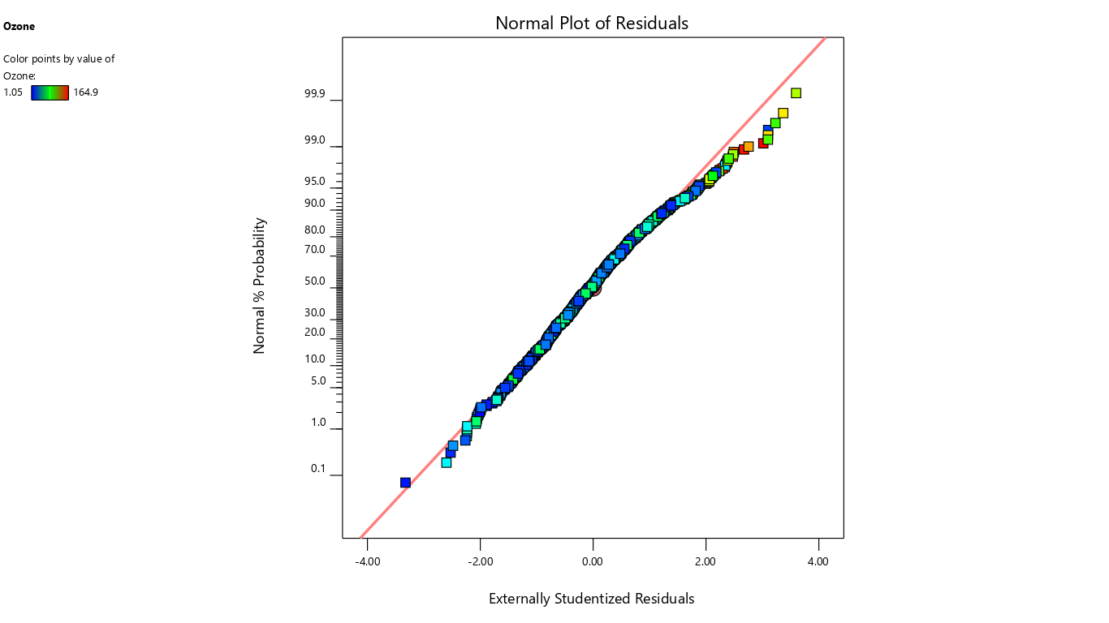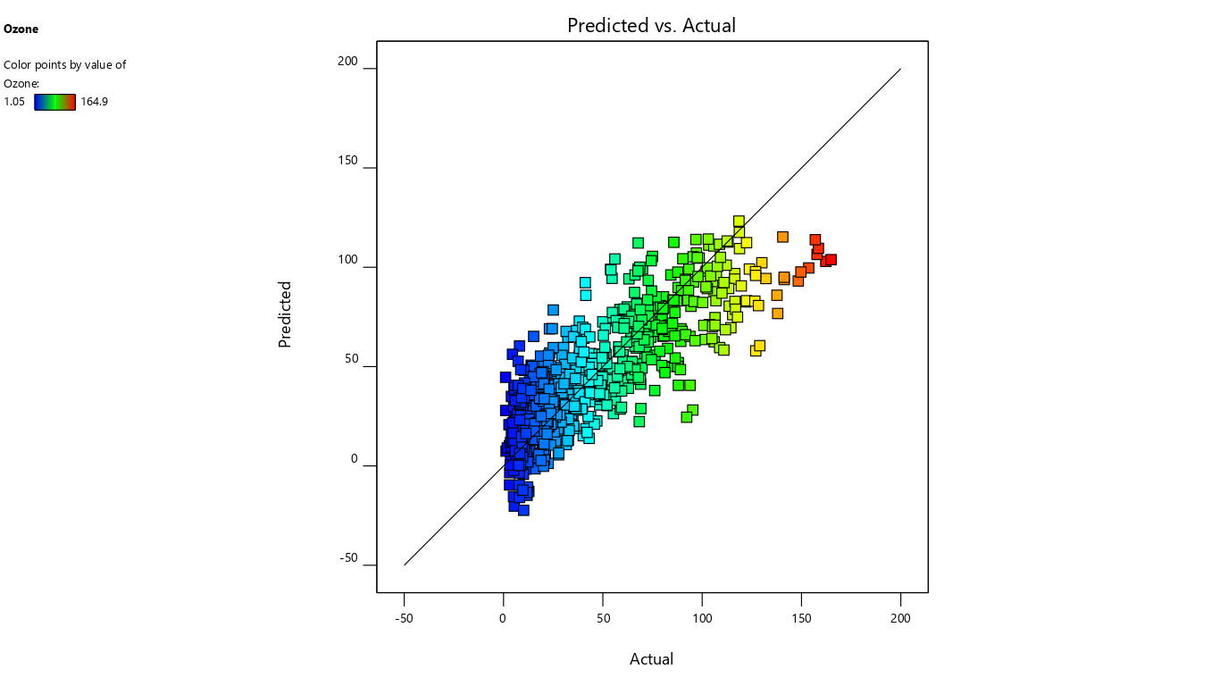

### Constraints

|  |  |  |  |  |  |  |
| --- | --- | --- | --- | --- | --- | --- |
| **Name** | **Goal** | **Lower Limit** | **Upper Limit** | **Lower Weight** | **Upper Weight** | **Importance** |
| A:PM2.5 | is in range | 10 | 994 | 1 | 1 | 3 |
| B:PM10 | is in range | 25 | 836 | 1 | 1 | 3 |
| C:NO | is in range | 0.37 | 140 | 1 | 1 | 3 |
| D:NO2 | is in range | 7.15 | 115 | 1 | 1 | 3 |
| E:NOX | is in range | 5.77 | 143 | 1 | 1 | 3 |
| F:NH3 | is in range | 10.13 | 119 | 1 | 1 | 3 |
| G:SO2 | is in range | 0.9 | 58.02 | 1 | 1 | 3 |
| H:CO | is in range | 0.01 | 6.9 | 1 | 1 | 3 |
| Ozone | minimize | 5 | 25 | 1 | 1 | 5 |

